SQT UNIT:4
1a) What is Test Automation, and what is its primary goal in software testing?
Test Automation is the process of using specialized software tools to automatically execute pre-scripted tests on a software application before it is released into production. Instead of running tests manually, automation tools carry out repetitive but necessary testing tasks, compare actual results with expected outcomes, and generate detailed reports.
Primary Goal of Test Automation in Software Testing:
The main goal is to improve the efficiency, effectiveness, and coverage of the testing process by automating repetitive and time-consuming tasks.
More specifically, its goals include:
- Increase speed: Run tests faster than manual execution.
- Ensure consistency: Avoid human error in repetitive testing.
- Improve coverage: Execute a large number of test cases across different environments, browsers, and devices.
- Enable regression testing: Quickly verify that new changes haven’t broken existing functionality.
- Save costs long-term: Though setup is expensive, it reduces effort and cost for repeated test runs.
- Facilitate continuous integration (CI/CD): Allow automated testing in DevOps pipelines for quicker releases.
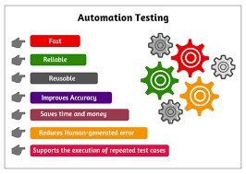

b) Differentiate between Manual Testing and Automation Testing. Provide at least three key differences.
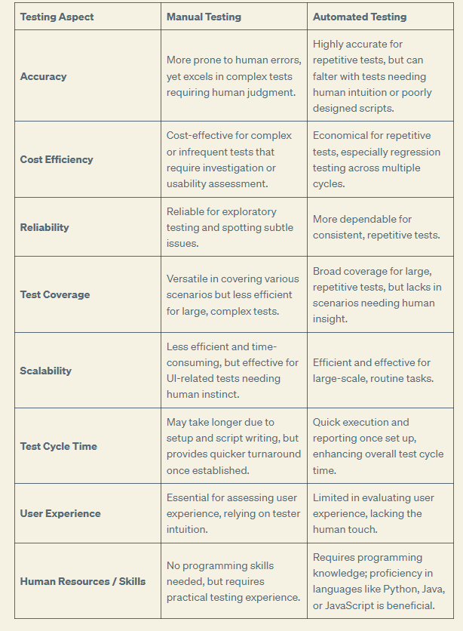

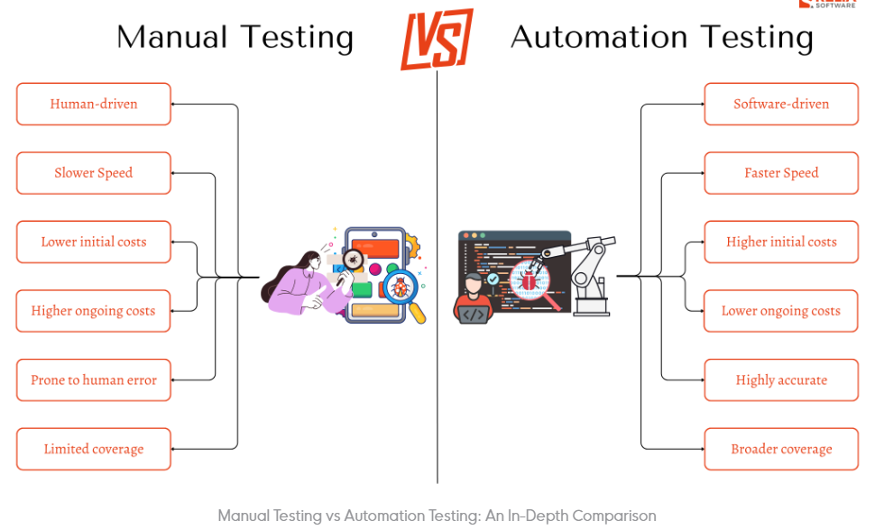

2a) List at least five benefits of implementing Test Automation in a software development project
Ans:
Test Automation:
Test Automation is the process of using specialized software tools to execute pre-scripted test cases on an application automatically. Instead of executing tests manually, automation tools like Selenium, JUnit, TestNG, Cypress, and QTP perform the testing tasks, compare actual outcomes with expected results, and generate reports.
Benefits of Implementing Test Automation
- Faster Execution of Tests
  - Automated test scripts can execute much faster than manual testing, especially for repetitive or lengthy test cases.
  - This helps speed up regression testing and reduces the overall release cycle time.
- Improved Accuracy and Reliability
  - Manual testing is prone to human errors, especially when executing the same test repeatedly.
  - Automated tests, once written correctly, always follow the same steps with precision, ensuring accurate and reliable results.
- Reusability of Test Scripts
  - Test scripts can be reused across different versions, builds, and even multiple projects with minimal modification.
  - This reduces the effort needed to create tests for every release and increases efficiency.
- Better Test Coverage
  - Automation allows running a large number of test cases in a limited time.
  - It helps cover multiple platforms, browsers, operating systems, and devices, ensuring that the application works in all expected environments.
- Support for Agile and CI/CD
  - In modern development practices, such as Agile and DevOps, continuous testing is essential.
  - Automated tests integrate easily with CI/CD pipelines, providing quick feedback whenever code changes are pushed, thus enabling faster delivery.
- Cost-Effective in the Long Run
  - Although automation requires initial investment (tools, framework setup, and skilled resources), it saves cost in the long run.
  - Once test scripts are developed, they can be executed multiple times without additional effort, lowering overall testing expenses.
- Early Detection of Defects
  - Automated testing allows frequent execution of test cases throughout the development lifecycle.
  - This helps detect bugs early in the software development process, reducing the cost and effort of fixing defects later.
- Enables Performance and Load Testing
  - Certain types of tests, such as load, stress, and performance testing, cannot be effectively performed manually.
  - Automation tools can simulate thousands of users to measure system performance under heavy loads.

- Parallel and Distributed Execution
  - Automation frameworks allow executing multiple test cases in parallel across different environments.
  - This reduces overall execution time and ensures faster feedback to developers.
b) What types of testing are generally well-suited for automation? Provide examples.
Types of Testing Well-Suited for Automation:
- Regression Testing
  - Ensures that new code changes do not break existing functionality.
  - Example: After adding a new "wishlist" feature in an e-commerce site, automation can re-run checkout, login, and payment tests to verify nothing else is broken.
- Smoke and Sanity Testing
  - Quick checks to verify basic functionality of the application after a new build or deployment.
  - Example: Running automated tests to confirm that the login page loads and the dashboard opens without errors.
- Functional Testing
  - Verifies that individual features of the software work as expected.
  - Example: Testing the "Add to Cart" button to ensure it correctly updates the cart total.
- Data-Driven Testing
  - Useful when the same test needs to be executed multiple times with different sets of input data.
  - Example: Automating a "login" test with hundreds of valid and invalid username/password combinations.
- Performance, Load, and Stress Testing
  - Automation tools can simulate thousands of virtual users to test system behavior under heavy load.
  - Example: Checking how a banking app handles 10,000 concurrent transactions.
- Cross-Browser and Cross-Platform Testing
  - Ensures the application works correctly across different browsers, devices, and operating systems.
  - Example: Automating UI tests to verify that a website’s layout and functionality are consistent on Chrome, Firefox, and Safari.
- API Testing
  - Automated tools can send requests and validate responses quickly and repeatedly.
  - Example: Testing whether the payment gateway API returns the correct success or failure status.
- Repetitive and High-Volume Testing
  - Any test case that is run very frequently or involves a large dataset is suitable for automation.
  - Example: Running automated calculations for millions of financial transactions.

3)What is a Test Automation Tool, and give examples of popular tools for web application testing? What are some common challenges or disadvantages associated with Test Automation?
Ans:
A Test Automation Tool is a software application used to automate the process of executing test cases, comparing actual results with expected outcomes, and generating test reports. Instead of performing tests manually, these tools run scripts automatically, saving time, reducing errors, and ensuring consistency in testing.
Examples of Popular Test Automation Tools for Web Application Testing
- Selenium – An open-source tool widely used for automating web applications across different browsers and platforms.
- Cypress – A modern tool designed for fast, reliable testing of web applications, especially front-end components.
- Playwright – Developed by Microsoft, supports automation across Chromium, Firefox, and WebKit with powerful parallel testing.
- TestComplete – A commercial tool that supports functional UI testing for web, desktop, and mobile applications.
- Puppeteer – A Node.js library that provides a high-level API to control Chrome or Chromium browsers.
- Katalon Studio – An all-in-one automation tool supporting web, API, and mobile testing with a user-friendly interface.

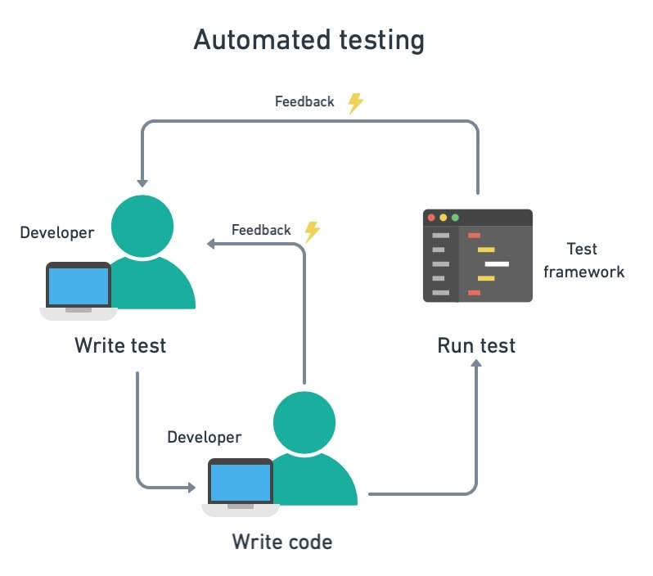

Common Challenges / Disadvantages of Test Automation
- High Initial Cost
  - Setting up automation requires investment in tools, frameworks, infrastructure, and skilled testers.
- Maintenance Overhead
  - Test scripts need frequent updates when the application UI or functionality changes.
  - Can become expensive and time-consuming for dynamic applications.
- Not Suitable for All Testing Types
  - Tests that require human judgment, such as usability, exploratory, or UI look-and-feel testing, cannot be fully automated.
- Complex Setup and Learning Curve
  - Many tools require programming knowledge and complex configuration, which may not be easy for beginners.
- False Positives / False Negatives
  - Automation scripts may fail due to tool issues, environment problems, or improper synchronization, leading to misleading results.
- Initial Time Investment
  - Creating reliable automated test suites takes significant time before benefits are realized.
- Tool Limitations
  - Some tools may not support all browsers, devices, or advanced test scenarios, requiring additional plugins or tools.

4a)What is a Test Automation Framework, and why is it important to use one?
Ans:
A Test Automation Framework is a set of guidelines, best practices, and reusable components designed to create and manage automated test scripts efficiently. It provides a structured approach to writing, organizing, and executing tests by combining coding standards, libraries, tools, and test data management.
“It is a foundation or blueprint that helps testers build and run automation scripts in a systematic and maintainable way”.
Test Automation Framework Importance:
- Reusability of Code
  - Common functions and utilities can be reused across multiple test cases, reducing duplication.
- Maintainability
  - Makes it easier to update and maintain scripts when application features change.
- Consistency and Standardization
  - Provides a uniform structure for writing tests, improving readability and collaboration among team members.
- Improved Test Coverage
  - Supports execution of different types of tests (functional, regression, data-driven, etc.) with ease.
- Integration with Tools
  - Easily integrates with CI/CD tools (like Jenkins, GitHub Actions) for continuous testing and faster feedback.
- Scalability
  - Can handle a growing number of test cases and adapt to complex project requirements.
- Detailed Reporting and Logging
  - Most frameworks provide built-in reporting mechanisms, making it easy to analyze results.
- Efficiency and Cost-Effectiveness
  - Saves time and effort by reducing repetitive coding and automating execution, which lowers long-term testing costs.

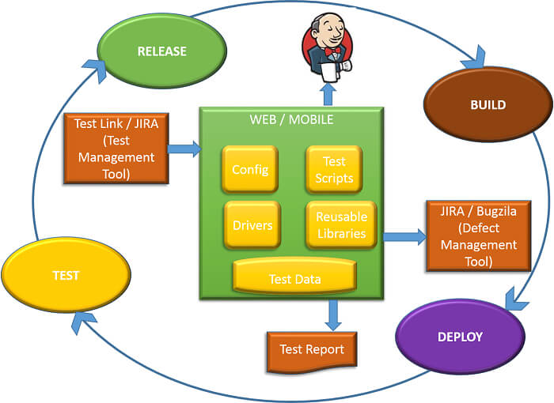
Example UseCase of Test Automation Framework

b)Describe three common types of Test Automation Frameworks and their distinguishing characteristics.
Ans:
1. Data-Driven Framework
Description:
- In this framework, test scripts are separated from the test data.
- Test cases can be executed multiple times with different sets of input data stored in external files such as Excel, CSV, XML, or databases.
Distinguishing Characteristics:
- Input and expected results are stored externally.
- Single test script can handle multiple data sets.
- Increases test coverage by testing multiple data combinations.
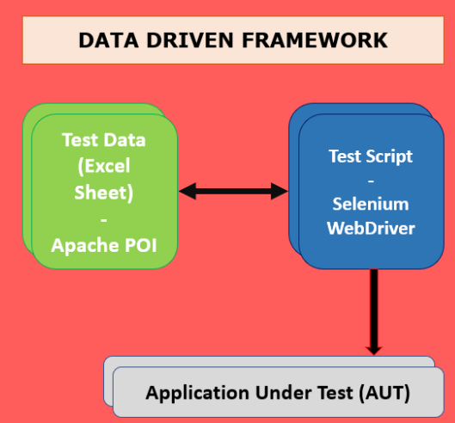
Example:
Testing a login feature with multiple username/password combinations stored in an Excel sheet.

2. Keyword-Driven Framework
Description:
- Also known as table-driven testing.
- Uses a set of keywords (actions) that represent operations to be performed on the application under test.
- Non-technical testers can create test cases by writing keywords in an external file without knowing the underlying code.
Distinguishing Characteristics:
- Keywords represent actions (e.g., ClickButton, EnterText, VerifyPage).
- Test steps are written in tabular format (Excel, XML, etc.).
- Easy for non-programmers to contribute to test creation.
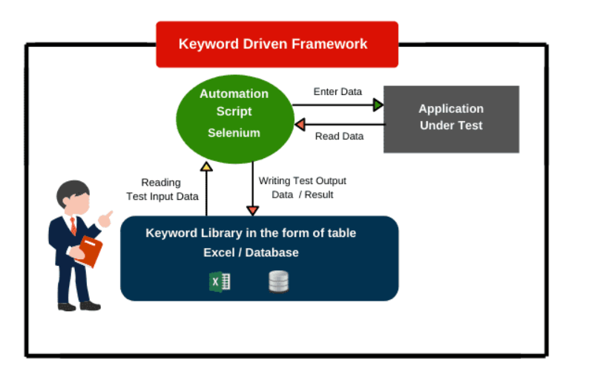
Example:
Automating a form submission using keywords like OpenBrowser → EnterText → ClickSubmit → VerifyMessage.

3. Hybrid Framework
Description:
- A combination of Data-Driven and Keyword-Driven frameworks (and sometimes Modular).
- It leverages the strengths of multiple frameworks to make testing more flexible and powerful.
Distinguishing Characteristics:
- Uses both external test data and keyword-driven actions.
- Provides high reusability and scalability.
- Suitable for complex and large-scale applications.
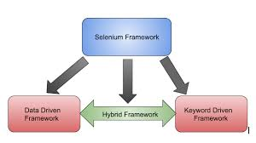

Example:
Testing an e-commerce checkout process using external test data (credit card details, shipping addresses) along with keywords (AddToCart, EnterAddress, VerifyOrder).

5)Why is it important to consider the "domain" or type of application when recommending an automation framework or tool
Ans:
The domain or type of application (e.g., web, mobile, desktop, API, embedded systems, gaming, etc.) directly affects which framework or tool will be most effective. Different domains have unique requirements, technologies, and challenges, so using the wrong tool may lead to inefficiency, poor coverage, or even tool incompatibility.
- Technology Stack Support
  - Applications are built on different tech stacks (Java, .NET, Angular, React, iOS/Android, etc.).
  - Example: Selenium supports web UIs, but for desktop apps you’d need WinAppDriver or TestComplete.
- Application Type (Web, Mobile, API, Desktop, Embedded)
  - The type of application determines the tool.
  - Example: Appium for mobile, Postman/RestAssured for APIs, Cypress/Playwright for modern web apps.
- User Interaction Complexity
  - Some apps (games, multimedia, AR/VR) require complex gestures, touch, or 3D interactions that general tools cannot handle.
  - Example: A 3D gaming app may require custom automation libraries, not Selenium.
- Domain-Specific Testing Requirements
  - Banking → security and data accuracy.
  - Healthcare → compliance with HIPAA, audit trails, strict validation.
  - Retail → cross-browser, usability, and scalability testing.
- Performance Needs
  - Some domains need stress/load testing at scale.
  - Example: E-commerce websites during Black Friday require JMeter/LoadRunner to simulate thousands of users.
- Cross-Platform Requirements
  - Apps that must run across browsers, OS, and devices require tools that support multi-environment execution.
  - Example: Selenium Grid for browser testing, Appium for Android/iOS.
- Integration with CI/CD Pipelines
  - Enterprise and SaaS apps with frequent releases need frameworks that work with Jenkins, GitHub Actions, Azure DevOps, etc.
  - Example: A fintech app with daily builds benefits from a CI/CD-friendly framework.
- Scalability and Maintenance
  - Complex apps need reusable, modular frameworks to handle thousands of test cases.
  - Example: A large ERP system would require a Hybrid Framework (combining data-driven + keyword-driven).
- Cost and Licensing Constraints
  - Some domains (like startups or academic projects) prefer open-source tools (Selenium, Cypress).
  - Enterprise projects may invest in commercial tools (TestComplete, UFT) with better support.
6)State and explain advantages and disadvantages of Domain Testing.
Ans:
Domain Testing is a software testing technique in which the input domain (range of possible inputs) of a program is divided into partitions or classes, and test cases are designed by selecting representative values from each class.
Example: If a system accepts age between 18–60, domain testing will check values at boundaries (18, 60) and within ranges (20, 45, etc.).
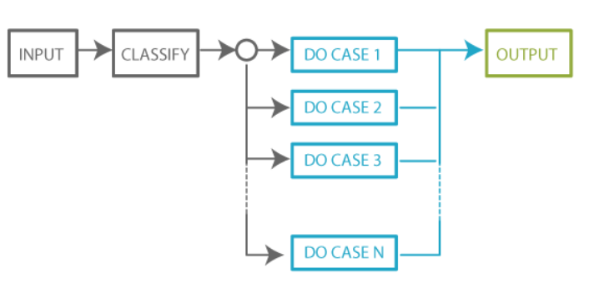
Advantages of Domain Testing
- Reduces Number of Test Cases
  - Instead of testing all possible inputs, testers only need to test representative values from partitions.
  - Saves time and effort.
- Effective in Finding Boundary Errors
  - Boundary Value Analysis (BVA) ensures that defects at the edge of valid/invalid input ranges are detected.
- Improves Test Coverage
  - Ensures that all input classes are tested at least once, increasing coverage.
- Simple and Easy to Apply
  - Concept is straightforward, and implementation doesn’t require complex tools.
- Early Detection of Defects
  - Helps identify logical and calculation errors in programs early in development.
- Cost-Effective
  - Minimizes redundant test cases, saving execution time and resources.
Disadvantages of Domain Testing
- Not Suitable for Complex Inputs
  - Works best for numeric ranges and simple input domains; less effective for complex data (e.g., multimedia, encrypted inputs).
- May Miss Defects Outside the Domain
  - If invalid classes or unexpected inputs are not considered, some bugs might go undetected.
- Limited to Defined Boundaries
  - Focuses on boundaries and partitions but may overlook logical errors in workflow or integration.
- Assumption of Equal Behavior in Domain
  - Assumes that if one value in a partition works, all will work — which may not always hold true.
- Not Effective for Non-Numeric Inputs
  - Works poorly for string, UI-based, or rule-driven inputs without clear ranges.
- Requires Domain Knowledge
  - Testers must clearly understand input ranges and partitions; mistakes in partitioning can lead to incomplete testing.

7)You need to set up automation for a desktop application (e.g., a Windows-based application). What challenges might you face, and what tool categories would you consider?
Ans:
Challenges in Automating Desktop Applications
- Limited Tool Support
  - Most popular tools (like Selenium, Cypress) are built for web applications, not desktop apps.
  - Finding the right tool for the specific technology stack (WinForms, WPF, JavaFX, etc.) can be tricky.
- Technology/Framework Dependency
  - Desktop apps may use different UI frameworks (Win32, .NET, MFC, Java Swing, Electron).
  - A single tool may not support all technologies.
- Object Identification Issues
  - Locating and interacting with desktop UI elements can be more complex than web locators (like XPath, CSS).
  - Dynamic controls, hidden elements, or custom UI components may not be easily recognized.
- Environment Constraints
  - Tests must run on specific operating systems (Windows, Mac, Linux).
  - Virtual environments and compatibility issues may arise.
- Integration with CI/CD Pipelines
  - Unlike web automation, desktop app automation is harder to integrate into DevOps pipelines due to platform dependencies.
- Maintenance Overhead
  - Frequent application updates (UI changes, new controls) can break test scripts, requiring ongoing maintenance.
- Performance and Stability Issues
  - Desktop apps may run differently on various hardware setups, affecting test consistency.
Tool Categories to Consider for Desktop Application Automation
- Commercial Tools (Powerful, All-in-One)
  - UFT (Unified Functional Testing / QTP) → Supports Windows-based apps, robust object recognition.
  - TestComplete → Widely used for desktop automation, supports .NET, WPF, Java, Delphi apps.
  - Ranorex → Strong support for desktop, mobile, and web apps with good reporting.
- Open-Source Tools
  - WinAppDriver (Windows Application Driver) → Microsoft’s open-source tool, works with WebDriver protocol.
  - Winium → Selenium-based tool for automating Windows desktop apps.
  - AutoIt → Lightweight scripting tool for automating Windows GUIs and handling pop-ups.
  - Pywinauto (Python library) → Useful for automating simple Windows applications.
- RPA (Robotic Process Automation) Tools
  - UiPath, Automation Anywhere, Blue Prism → Useful for automating repetitive desktop workflows across multiple apps.

8)For mobile application testing (IOS and Android native apps), what factors influence tool and framework selection, and what common approaches are used?
Ans:
Factors Influencing Tool & Framework Selection for Mobile Application Testing
- Platform Support (iOS, Android, Hybrid, Native)
  - Some tools support only Android, some iOS, and some both.
  - Example: Espresso → Android only, XCUITest → iOS only, Appium → both.
- Application Type
  - Native apps (built specifically for iOS/Android),
  - Hybrid apps (web + native),
  - Mobile web apps (browser-based).
  - Tool must support the right type.
- Programming Language Support
  - Teams prefer tools compatible with their existing tech stack.
  - Example: Espresso uses Java/Kotlin; Appium allows multiple languages (Java, Python, C#, JS).
- CI/CD Integration
  - Tool should integrate with DevOps pipelines (Jenkins, GitHub Actions, GitLab CI).
- Cross-Platform Execution
  - If the same tests should run on both Android & iOS, a cross-platform tool (like Appium, Detox) is better.

- Device Coverage
  - Need for real devices vs emulators/simulators.
  - Tool should support cloud-based device farms (BrowserStack, Sauce Labs, Firebase Test Lab).
- Community & Ecosystem
  - Open-source tools (Appium, Espresso, XCUITest) have large communities.
  - Commercial tools (Ranorex, Perfecto, Kobiton) offer enterprise support.
- Performance & Stability
  - Some frameworks (like Espresso, XCUITest) run inside the device, making them faster and more stable than cross-platform tools.
- Budget & Licensing
  - Open-source tools are cost-effective but may need more setup.
  - Commercial tools provide enterprise support at higher cost.
Common Approaches Used in Mobile Test Automation
- Cross-Platform Testing (Single Codebase for iOS & Android)
  - Example Tools: Appium, Detox, Calabash
  - Advantage: Reuse test scripts across platforms.
  - Disadvantage: Slower execution than native tools.
- Platform-Specific / Native Testing
  - Espresso (Android) and XCUITest (iOS).
  - Advantage: Fast, stable, and directly integrated with the OS.
  - Disadvantage: Separate test suites needed for iOS & Android.
- Cloud-Based Device Testing
  - Tools: BrowserStack, Sauce Labs, Firebase Test Lab, AWS Device Farm.
  - Advantage: Test on real devices across multiple OS versions and screen sizes.
  - Disadvantage: Paid services; network latency can affect results.
- Hybrid Approach (Combination of Native + Cross-Platform)
  - Example: Use Espresso for Android, XCUITest for iOS, and run end-to-end flows with Appium.
- RPA and Scriptless Automation
  - Tools like Kobiton, Perfecto, TestComplete Mobile.
  - Useful for business teams with less coding knowledge.

9) What is the Process of Automation testing? Explain with examples.
Ans:
Automation Testing:
Automation Testing is a software testing technique where specialized tools, scripts, and frameworks are used to automatically execute test cases, compare actual outcomes with expected results, and generate reports.
Instead of executing tests manually, automation helps speed up the process, improve accuracy, and support continuous integration and delivery (CI/CD).
Process of Automation Testing:
Automation testing follows a structured process, much like the software testing life cycle (STLC), but with focus on test scripts, tools, and frameworks.
1. Requirement Analysis
- Understand which features, test cases, and modules need automation.
- Decide the scope: Which test cases are stable and repetitive enough to automate?
- Example: In an e-commerce app, login, search, add-to-cart, and checkout workflows are repetitive and suitable for automation.
2. Tool Selection
- Choose the right automation tool based on technology stack, budget, and application type.
- Example:
  - For web apps → Selenium, Cypress.
  - For desktop apps → WinAppDriver, TestComplete.
  - For mobile apps → Appium, Espresso, XCUITest.
3. Test Planning & Framework Design
- Define strategy, scope, test data, and reporting needs.
- Select framework type (Data-Driven, Keyword-Driven, Hybrid, BDD).
- Example: A banking project may use a Hybrid framework combining Data-Driven (Excel input) and Keyword-Driven testing.

4. Test Case Development (Scripting)
- Write automated test scripts using chosen tool and framework.
- Apply coding best practices (modular, reusable functions).
- Example (Selenium + Java):
- driver.get("https://demoapp.com");
- driver.findElement(By.id("username")).sendKeys("testuser");
- driver.findElement(By.id("password")).sendKeys("password123");
- driver.findElement(By.id("login")).click();
5. Test Environment Setup
- Configure hardware, software, test data, and tools.
- Ensure CI/CD pipelines are ready if continuous testing is planned.
- Example: Setting up Jenkins pipeline to trigger Selenium scripts after each code commit.
6. Test Execution
- Run automated scripts on different browsers, devices, or environments.
- Tests can be executed in parallel for faster results.
- Example: Running Selenium Grid to test on Chrome, Firefox, and Edge simultaneously.
7. Result Analysis & Reporting
- Tools generate logs, screenshots, and reports for passed/failed test cases.
- Testers analyze failures to distinguish between script errors and real application bugs.
- Example: Using Extent Reports or Allure Reports for clear pass/fail dashboards.
8. Maintenance of Test Scripts
- Scripts need updates whenever the application UI or functionality changes.
- Automation suite must evolve with the software.
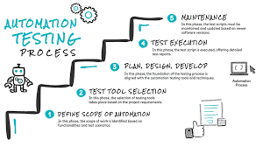
- Example: If the “Login” button ID changes from loginBtn to submitBtn, the script must be updated.

10) What is the purpose of Reporting in Test Automation, and what key information should a good automation report provide?
Ans:
Test Automation Report:
A Test Automation Report is the final output generated after executing automated test scripts. It summarizes test execution results in a structured way, providing insights into what passed, what failed, why it failed, and how the system performed.
Metrics Of Test Automation Report:
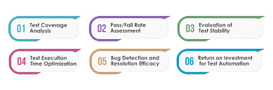

Purpose of Reporting in Test Automation
- Track Test Execution Status
  - Reports show how many test cases passed, failed, skipped, or were blocked.
- Provide Quick Feedback
  - Developers and QA teams can immediately see if new changes broke existing functionality.
- Aid in Debugging
  - Reports with logs, screenshots, and error messages help quickly identify root causes of failures.
- Enable Transparency
  - Stakeholders (managers, product owners, clients) get a clear view of software quality without needing to read test scripts.
- Support Continuous Integration (CI/CD)
  - Automated reports integrate with Jenkins, GitLab, or Azure pipelines, ensuring continuous monitoring of quality.
- Decision-Making
  - Helps decide if a build is stable enough for release, or if additional fixes are required.

Key Information in a Good Automation Report
- Test Summary
  - Total number of tests executed.
  - Number of passed, failed, skipped, and pending tests.
- Execution Details
  - Start and end time of execution.
  - Duration of test runs.
  - Environment details (OS, browser, device).
- Error/Failure Logs
  - Detailed error messages and stack traces for failed cases.
  - Screenshots or video captures at the point of failure.
- Test Case-Level Results
  - Status of each test case (pass/fail/skip).
  - Test data used for execution.
- Trends & Metrics (Optional but Valuable)
  - Historical comparison of test results across multiple runs.
  - Defect density or failure patterns over time.
- Integration Support
  - Links to bug tracking systems (e.g., Jira, Bugzilla).
  - Links to CI/CD pipeline dashboards.
Examples of Reporting Tools
- Extent Reports (detailed HTML reports with graphs, screenshots).
- Allure Reports (beautiful visual reports with history tracking).
- JUnit/TestNG Reports (standard XML/HTML for Java projects).
- Jenkins Plugins (for pipeline-integrated reporting).

